# Week 12 Assignment

Table of Contents

[Week 12 Assignment 1](#_Toc404000672)

[Cricket league Graph Database: 1](#_Toc404000673)

[Use Case: 1](#_Toc404000674)

[Description of the data model: 1](#_Toc404000675)

[Sample data: 2](#_Toc404000676)

[The code for queries to acquire and manage the data in Neo4j : 4](#_Toc404000677)

[The code for queries to access and analyze the data for your use case: 5](#_Toc404000678)

## Cricket league Graph Database:

### Use Case:

The use case I chose to represent in Graph database is the data of a League of Cricket played between three teams from the Country India, Australia and England. Please note that these data are dummy data and they are not real matches played.

The database will store the information of the Players and the teams and the matches they played and what are the results of the matches. The data I chose is very simple for this assignment. But we can store more information of the like which player scored how many runs. What are the numbers of wickets taken by a bowler in a match? Who was the man of the match of that game? On storing these data it will be very easier to retrieve a piece of data like who won the most number of matches or the man of the match for all the matches.

### Description of the data model:

The data model I chose is very simple. There are three kinds of nodes – Players, Team, Match

Players – Name

Team – Country

Match – Match

The relationships that exist between the nodes are:

PlayingWith: Players ->[r:PlayingWith{Role}] ->Team

Wins: Team -[r:Wins{ByRun,ByWicket}] - >Matches

Losses: Team ->Matches

Provide below is the screenshot of the

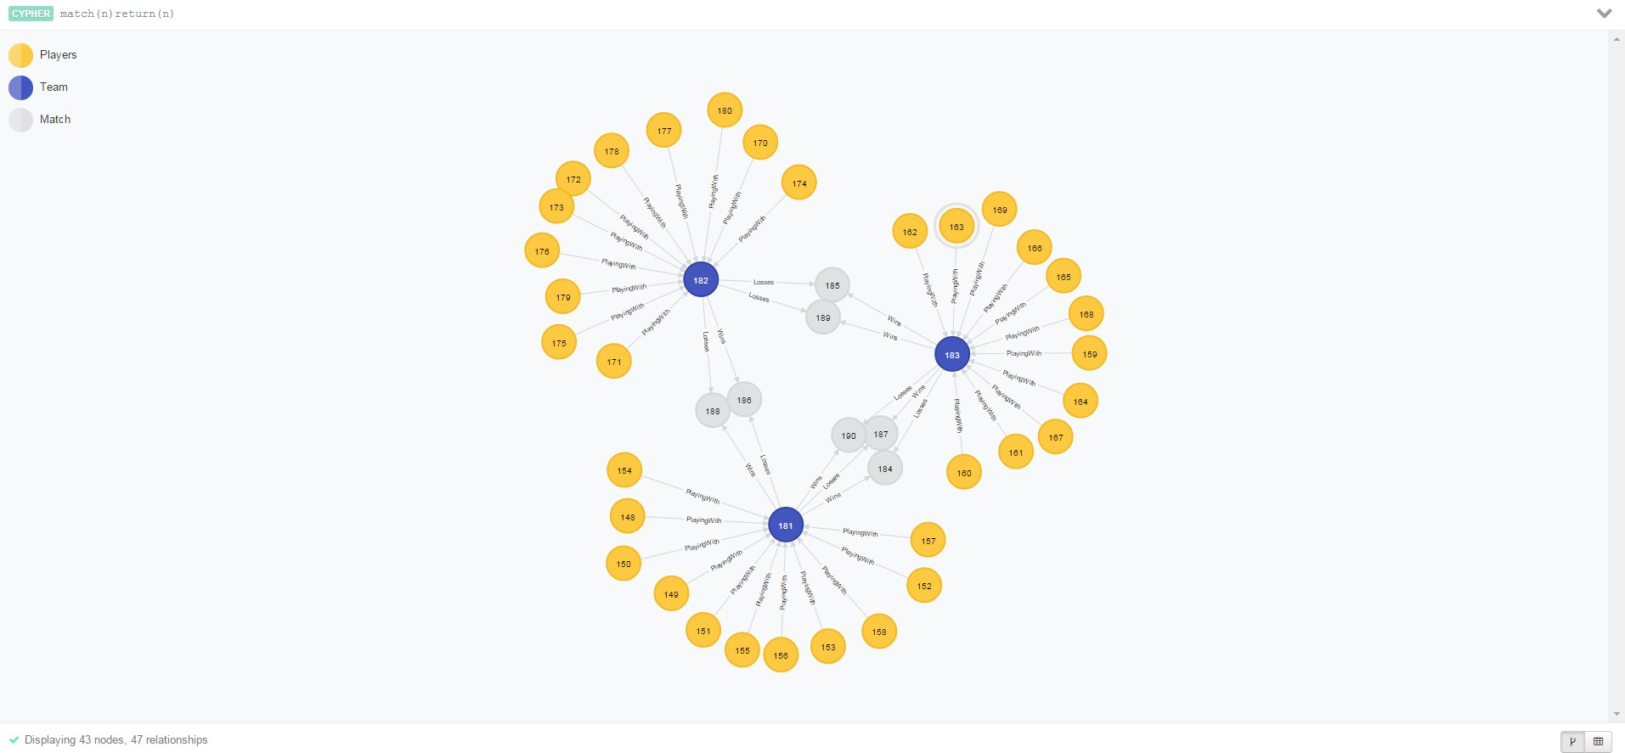

### Sample data:

The sample data in the excel format are given below:

CricketPlayers:

|  |  |  |  |  |  |  |  |  |  |  |  |  |  |  |  |  |  |  |  |  |  |  |  |  |  |  |  |  |  |  |  |  |  |  |  |  |  |  |  |  |  |  |  |  |  |  |  |  |  |  |  |  |  |  |  |  |  |  |  |  |  |  |  |  |  |  |  |  |  |  |  |  |  |  |  |  |  |  |  |  |  |  |  |  |  |  |  |  |  |  |  |  |  |  |  |  |  |  |  |  |  |  |  |  |  |  |  |  |  |  |  |  |  |  |  |  |  |  |  |  |  |  |  |  |  |  |  |  |  |  |  |  |  |  |  |  |  |  |  |  |  |  |  |  |
| --- | --- | --- | --- | --- | --- | --- | --- | --- | --- | --- | --- | --- | --- | --- | --- | --- | --- | --- | --- | --- | --- | --- | --- | --- | --- | --- | --- | --- | --- | --- | --- | --- | --- | --- | --- | --- | --- | --- | --- | --- | --- | --- | --- | --- | --- | --- | --- | --- | --- | --- | --- | --- | --- | --- | --- | --- | --- | --- | --- | --- | --- | --- | --- | --- | --- | --- | --- | --- | --- | --- | --- | --- | --- | --- | --- | --- | --- | --- | --- | --- | --- | --- | --- | --- | --- | --- | --- | --- | --- | --- | --- | --- | --- | --- | --- | --- | --- | --- | --- | --- | --- | --- | --- | --- | --- | --- | --- | --- | --- | --- | --- | --- | --- | --- | --- | --- | --- | --- | --- | --- | --- | --- | --- | --- | --- | --- | --- | --- | --- | --- | --- | --- | --- | --- | --- | --- | --- | --- | --- | --- | --- | --- | --- | --- |
| |  |  |  | | --- | --- | --- | | **Name** | **Team** | **Role** | | MS Dhoni | India | Captain | | Yuvraj Singh | India | Batsman | | Rohit Sharma | India | Batsman | | S Sreesanth | India | Bowler | | Ajinkya Rahane | India | Batsman | | Ishant Sharma | India | Bowler | | Ravindra Jadeja | India | All Rounder | | Manoj Tiwary | India | Batsman | | RP Singh | India | Bowler | | Virat Kohli | India | Batsman | | Piyush Chawla | India | All Rounder | | Michael Clarke | Australia | Captain | | Brad Haddin | Australia | Wicket Keeper | | John Hastings | Australia | All Rounder | | Bryce McGain | Australia | Bowler | | Nathan Coulter-Nile | Australia | Bowler | | Ryan Harris | Australia | All Rounder | | Marcus North | Australia | Batsman | | Andrew McDonald | Australia | All Rounder | | Ben Rohrer | Australia | Batsman | | Chris Rogers | Australia | Batsman | | Travis Birt | Australia | Batsman | | Alastair Cook | England | Captain | | David Murphy | England | Wicket Keeper | | Ed Joyce | England | Batsman | | James Tredwell | England | Bowler | | Michael Lumb | England | Batsman | | Dimitri Mascarenhas | England | All Rounder | | Joe Root | England | Batsman | | Steven Finn | England | Batsman | | Chris Woakes | England | Bowler | | Harry Gurney | England | Bowler | | Moeen Ali | England | All Rounder |   Match Results:   |  |  |  |  |  | | --- | --- | --- | --- | --- | | **Match** | **Win** | **Loss** | **WinByRuns** | **WInByWickets** | | Match 1 | India | Australia | 10 |  | | Match 2 | Australia | England | 54 |  | | Match 3 | England | India |  | 4 | | Match 4 | Australia | India | 12 |  | | Match 5 | India | England |  | 3 | | Match 6 | Australia | England |  | 2 | | Final | India | Australia | 3 |  | |  |  |
|  |  |  |
|  |  |  |
|  |  |  |
|  |  |  |
|  |  |  |
| The code for queries to acquire and manage the data in Neo4j : Creating Player nodes:  load csv with headers from "file:C:\\data\\CricketPlayers.csv" as players create (p1:Players {Name:players.Name})  Creating Team nodes:  Since I know that there are three teams I explicitly wrote the create statement. But with many teams we can clean up the data in R and get the unique values of the Teams from the CricktPlayers data.  create(t1:Team{Country:"India"})  create(t1:Team{Country:"Australia"})  create(t1:Team{Country:"England"})  Creating Match nodes:  load csv with headers from "file:C:\\data\\MatchResults.csv" as match create (m1:Match {Match:match.Match})  Creating PlayingWith relationship:  load csv with headers from "file:C:\\data\\CricketPlayers.csv" as playingWith match (p:Players {Name:playingWith.Name}), (t:Team{Country:playingWith.Team}) create (p)-[r:PlayingWith{Role:playingWith.Role}]->(t)  Creating Wins relationship:  load csv with headers from "file:C:\\data\\MatchResults.csv" as result match (t:Team{Country:result.Win}),(m:Match{Match:result.Match}) create (t)-[r:Wins{ByRun:result.WinByRuns},{ByWicket:result.WInByWickets}]->(m)  Creating Losses relationship:  load csv with headers from "file:C:\\data\\MatchResults.csv" as result match (t:Team{Country:result.Loss}),(m:Match{Match:result.Match}) create (t)-[r:Losses]->(m) |  |  |
|  |  |  |
|  |  |  |
|   The code for queries to access and analyze the data for your use case: Show the captains of the teams in the league:  match(p:Players)-[r:PlayingWith{Role:"Captain"}]->(t:Team) return p,r,t  The data in tabular format:   |  |  |  | | --- | --- | --- | | p | r | t | | {"Name":"MS Dhoni"} | {"Role":"Captain"} | {"Country":"India"} | | {"Name":"Michael Clarke"} | {"Role":"Captain"} | {"Country":"Australia"} | | {"Name":"Alastair Cook"} | {"Role":"Captain"} | {"Country":"England"} |   The data in graph format:  C:\Users\sonatushi\Desktop\ScreenHunter_12 Nov. 17 14.15.jpg  Show the matches won by India:  match(t:Team{Country:"India"})-[r:Wins]->(m:Match) return t,r,m  The data in tabular format: |  |  |
| |  |  |  | | --- | --- | --- | | t | r | m | | {"Country":"India"} | {"ByRun":"3","ByWicket":""} | {"Match":"Final"} | | {"Country":"India"} | {"ByRun":"","ByWicket":"3"} | {"Match":"Match 5"} | | {"Country":"India"} | {"ByRun":"10","ByWicket":""} | {"Match":"Match 1"} | |  |  |
| The data in graph format:  C:\Users\sonatushi\Desktop\ScreenHunter_14 Nov. 17 14.26.jpg |  |  |
|  |  |  |
|  |  |  |
|  |  |  |
|  |  |  |
|  |  |  |
|  |  |  |
|  |  |  |
|  |  |  |
|  |  |  |
|  |  |  |
|  |  |  |
|  |  |  |
|  |  |  |
|  |  |  |
|  |  |  |
|  |  |  |
|  |  |  |
|  |  |  |
|  |  |  |
|  |  |  |
|  |  |  |
|  |  |  |